Template for Biosignal InterpretationWorkshop 2016

A Author1¹, B Author2², C Author3¹, D Author4³,

1Department, University, Country;
2Department, University, Country;
3Department, University, Country;

Abstract
This article gives you step by step instructions to create your paper for the 8th International Workshop on Biosignal Interpretation (BSI 2016) to be held on November 1-3, 2016 in Osaka. Papers up to 4 pages should be submitted using this format through the workshop web site: www3.bpe.es.osaka-u.ac.jp/~BSI2016. You can use this template to prepare your manuscript. Abstract should not exceed 200 words. Please include 3 to 5 keywords at the end of your abstract in alphabetical order, separated by commas.

Keywords Biosignal and Image Interpretations, Conference Paper, Instructions
1 Introduction
Do not use abbreviations in the title. All papers must be submitted electronically in pdf format. The paper should be no more than four pages long. The paper should include the following sections: introduction, methods, results and conclusions. Each of them can have more than one sub- or subsub- sections.
In formatting your page, set left, top, and right margins to 19.1 mm and bottom margin to 25.4 mm. Use a two-column format. Left and right-justify your columns. Use automatic hyphenation and check spelling.
2 Methods
Describe your methods here.
Type sizes and typefaces to use are listed in Table 1. Briefly, abstract heading font is Times, 11pt, bold. Abstract text font is Helvetica, 10pt, italic. Keywords heading font is Times, 11pt, while the keywords font is Helvetica, 10pt, bold. Text font is Times 10pt. Headings font is Times, 12pt, bold. Title font is Times, 14pt, bold. Author names and affiliations font is Helvetica 12pt.
3 Results
Give your results here.
3.1 Tables and figures
Tables and figures can fit across both columns if necessary. Captions go beneath tables and figures. Large figures and tables may span across both columns. Avoid placing figures and tables before their first mention in the text. Use the abbreviation “Fig.” even at the beginning of a sentence. An example of figure is given in Fig. 1.

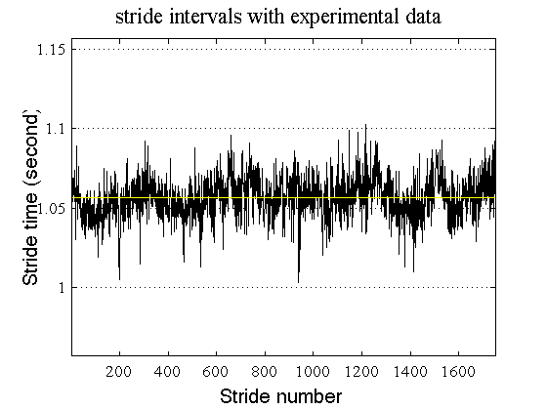
Figure 1: Example of figure.

Text | Point size | Type | Font
Title | 14 point | Bold | Times
Author line | 12 point |  | Helvetica
Institution line | 12 point |  | Helvetica
Abstract heading | 11 point | Bold | Times
All other headings | 12 point | Bold | Times
Abstract text | 10 point | Italic | Helvetica
References | 9 point |  | Helvetica
All other text | 10 point |  | Times
Table 1: Example table

3.2 References
Citations should appear in the text, in square brackets, and in their order of appearance [1]. The sentence punctuation follows the bracket [2]. Refer simply to the reference number, as in [3]. Capitalize only the first word in a paper title, except for proper nouns and element symbols. References font is Times, 10pt.
3.3 Abbreviations and Acronyms
Define abbreviations and acronyms the first time they are used in the text, even after they have already been defined in the abstract. Abbreviations that incorporate periods should not have spaces: write ‘C.N.R.S.,’ not ‘C. N. R. S.’.
3.4 Equations
Number equations consecutively with equation numbers in parentheses flush with the right margin, as in Eq.1. Use parentheses to avoid ambiguities in denominators. Punctuate equations with commas or periods when they are part of a sentence, as in Eq.1. An example of equation is given in the following:
$A+B=C$, (1)
where an example of equation is written. Be sure that the symbols in your equation have been defined before the equation appears or immediately following.
4 Conclusions
Type your conclusions here.
Acknowledgements
Add any acknowledgements here.
References
[1] A. Name. Title of the paper. Journal Name, 1:426-438, 2000.
[2] A. Name and B. Name. A very interesting paper. Journal Name, 1-129-161, 2011.
[3] B. Name, A.B. Name, and C. Name.Chapter title. In Editor A, editor B, Book Title, pages 225-239. Publisher, 2004.

Address for correspondence:
Name Surname
Institution
email address

